**10/31/2015: double print of instructions.. related to retrieval of previous sale**

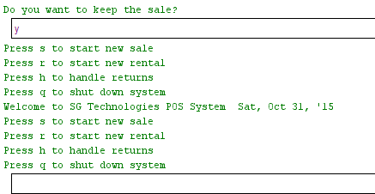

**10/31/2015: database path**

-currently the sale class uses a unix style path and assumes Database folder is inside of src, while rental class uses windows and assumes it’s in the same directory as src.

-going to fix this by moving database to the same directory as src, and adding an OS check to pointOfSale that decides which path-notation to use

-this should be pushed by ~2:30PM today (10/31)

**10/31/2015: cancel sale:**

shouldn’t exit the program, only shutdown should do that

**10/31/2015: invalid item number (sale) can be ignored by pressing something other than “e”**

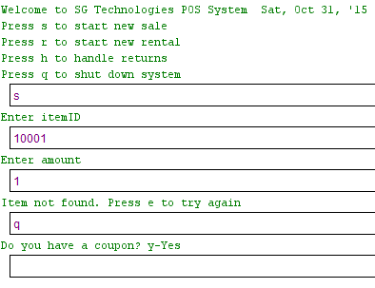

**10/31/2015: trailing spaces in userDatabase cause crash when you enter a phone number that doesnt exist in the DB**

this isnt urgent, as long as we’re careful not to accidentally leave any trailing spaces/characters that arent ints at the end of the userDatabase. but it should be handled before beta release. edit: fixed this by adding an exception catch and calling continue on any blank fields/non Long

